A STATISTICAL REVIEW OF GAZOS CREEK MURRELET RADAR DATA

by
Jake Verschuyl, Ph.D.
Hamer Environmental, Inc.

December 2008

GAZOS POPULATION TREND REGRESSION

In an effort to detect the local population trend of marbled murrelets (Brachyramphus marmoratus) at the Gazos Creek site near Pescadero, CA a repeated measures regression was run on the six years of existing marine radar data. The first analysis was conducted using repeated measures regression to investigate a potential trend in the total number of radar targets fitting the speed and size and time of day criteria for marbled murrelets over a 7 morning sampling period for 6 (not consecutive) years (Figure 1).

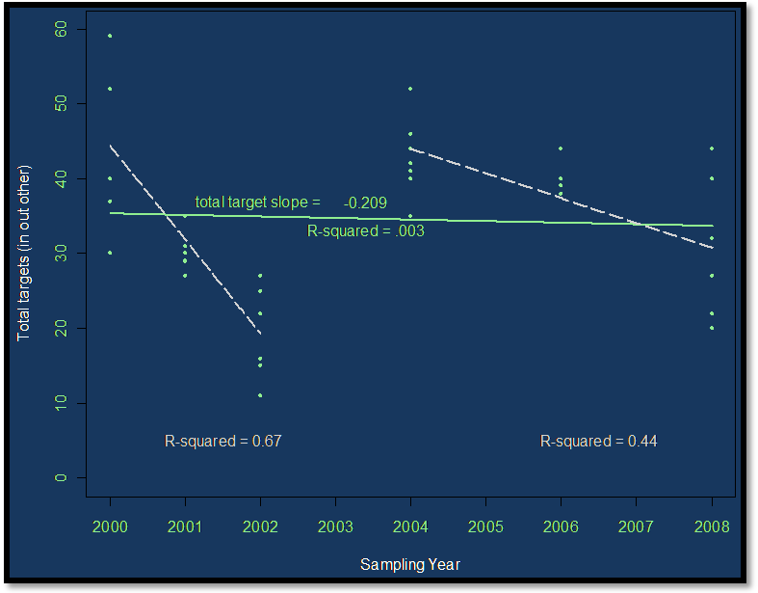
Figure 1. Regression results of the pre-dawn count of marbled murrelet targets by sampling year (P > 0.05 for the regression across all years; P < 0.01 for the 2000-2002 regression and the 2004-2008 regression).

The second analysis completed was a variation of the first, also using repeated measures regression to investigate a potential trend in the number of radar targets per survey morning, this time occurring before a cutoff time defined by the first documented Band-tailed pigeon flight (a potentially similar radar target). This goal of the second analysis was to remove any potentially confounded targets that may have been mistakenly included by some of the radar technicians.
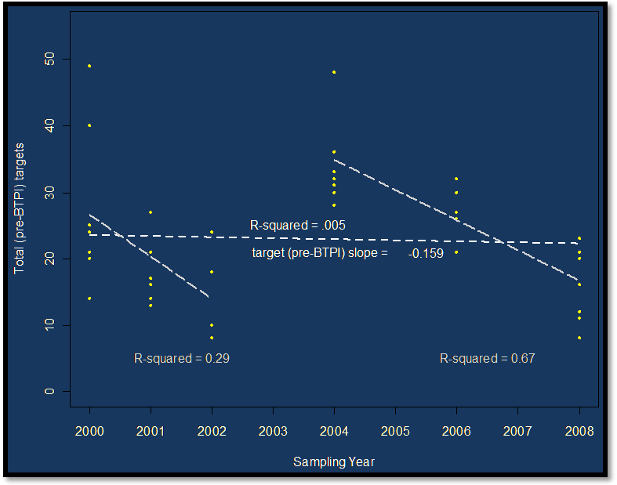
Figure 2. Regression results of the pre-dawn count of targets recorded before the first Band-tailed pigeon was detected by sampling year (P > 0.05 for the regression across all years; P < 0.01 for the 2000-2002 regression and the 2004-2008 regression).

The significance of the trends was assessed using the P-value associated with the slope term from the repeated measures regression. While the trend was slightly negative over the 6 sampling years for both analyses, neither regression resulted in a significant slope for the number of targets detected by sampling year. However, significant negative slopes were detected in both data sets when looking only at years 2000-2002 or 2004-2008 (dashed gray lines in Figures 1 & 2). There are many potential explanations for the upward shift between 2002-2004 (including changes in climate pattern, foraging resources, response to changes in local scavenger or predator populations, observer bias, etc.), but our data do not support further analysis of these factors.

POWER ANALYSIS

A power analysis was conducted using the existing data to assess how many additional years of survey would be necessary to detect different magnitudes of population trends with a range of power (Table 1; alpha = 0.05). The power analysis utilized the ratio of within (daily) to between year variance in the 6 existing years of data to determine how many additional years would be necessary (at two year spacing) to detect whether or not there is a certain trend in population.

Table 1. Additional years of data collection necessary (beyond 2008) to detect different magnitudes of population trends with a range of power.
 |  | POWER
Data Used | Detectable  Population Trend | 75 | 80 | 85 | 90 | 95
All targets | 1% | 30 | 31 | 33 | 35 | 38
 | 5% | 7 | 7 | 8 | 9 | 10
 | 10% | 2 | 3 | 3 | 4 | 4
 | 20% | 0 | 0 | 0 | 0 | 1
Targets flying directly in or out (no arcing flights) | 1% | 30 | 31 | 33 | 35 | 38
 | 5% | 7 | 7 | 8 | 9 | 10
 | 10% | 2 | 3 | 3 | 4 | 4
 | 20% | 0 | 0 | 0 | 0 | 1
All targets flying before 1st BTPI | 1% | 33 | 35 | 36 | 39 | 42
 | 5% | 8 | 8 | 9 | 10 | 11
 | 10% | 3 | 4 | 4 | 4 | 5
 | 20% | 0 | 0 | 1 | 1 | 1

Based on the power analysis and regression results, it seems wise to continue sampling for 2 additional years to determine whether or not there is a 10 % annual population decline (with 75% power). This would entail sampling efforts in 2010 and 2012. In addition, the additional sampling will allow us to assess whether the 2004-2008 trend continues or the population counts continue to gyrate back and forth.

